이근호님
Thanksgiving & Chuseok
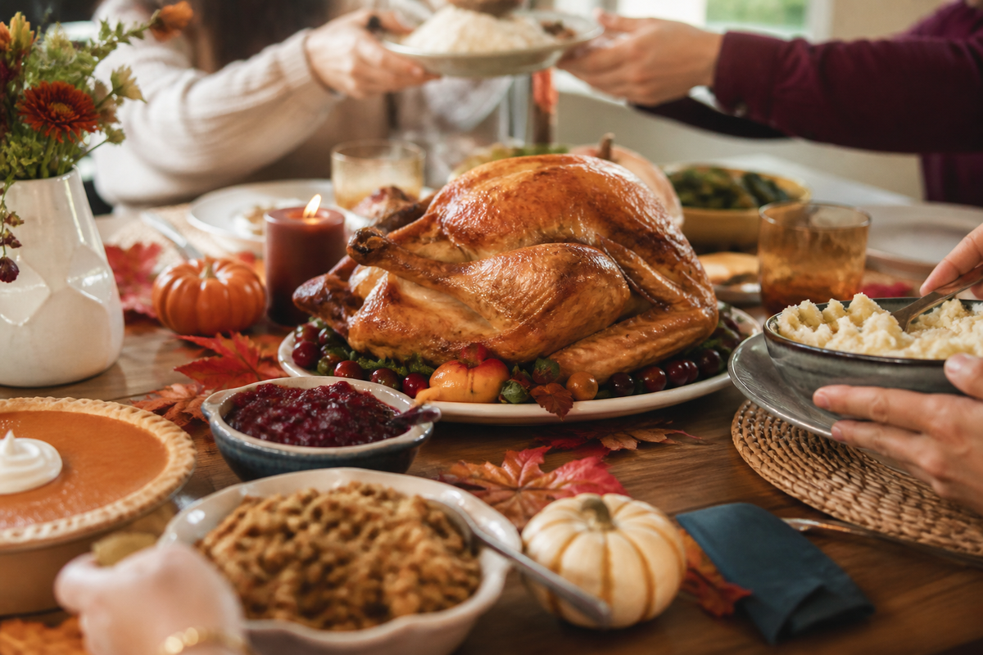
Warm-Up / Vocabulary / Reading / Comprehension / Idioms / Discussion

Warm-Up
Q What do you know about the history of Thanksgiving? Why do people celebrate it?
Q When is harvest season in Korea, and what foods are in season then?
Q What do Chuseok and Thanksgiving have in common?
Q What are you thankful for right now?

Vocabulary Preview
Match the words with their meanings.
_____ 1. harvest | a) a person who starts to live in a new place
_____ 2. lunar | b) shaped like a half-moon
_____ 3. honor | c) hunger, not enough food
_____ 4. ancestor | d) a large meal for a celebration
_____ 5. settler | e) food gathered from the land, such as grains and vegetables
_____ 6. colony | f) to show respect for
_____ 7. starvation | g) thankful
_____ 8. feast | h) of the moon
_____ 9. crescent | i) a new region settled by people from another country
_____ 10. customary | j) to make more beautiful
_____ 11. decorate | k) a family member from long ago
_____ 12. grateful | l) traditional, done as a custom
Reading 1 — Thanksgiving
1 Harvest festivals have been held throughout the world for thousands of years. The ancient Greeks held a three-day festival every autumn to honor Demeter, their goddess of grain, and the Romans held a fall festival for Ceres with music, games, parades, and a feast. The ancient Chinese celebrated a harvest festival on the fifteenth day of the eighth month of the lunar calendar — the same day as Chuseok — by baking round, yellow “moon” cakes.

2 The American Thanksgiving we know today began almost 400 years ago. In 1620, a group of about 100 people called the Pilgrims left England looking for religious freedom and a better life in America. When they arrived, their first winter was very difficult, and many of them died from starvation and disease.

3 The following year, Native Americans taught the settlers how to grow corn in the unfamiliar soil, how to collect sap from maple trees to make syrup, how to gather wild rice, and how to fish and hunt. In 1621, the Pilgrims had a very successful harvest and were able to put away food for the long winter ahead. They had a lot to be thankful for, so they planned a large feast and celebrated for three days, inviting the Native Americans who had taught them so much. In 1863, President Abraham Lincoln declared Thanksgiving a national holiday, and today Americans celebrate it on the fourth Thursday in November. Canadians celebrate earlier, on the second Monday in October, because their harvest comes earlier.

4 In both countries, Thanksgiving is a day to stop working and give thanks for one's life, health, family, food, and freedom. Most families share a festive meal with traditional dishes such as turkey and stuffing, mashed potatoes, cranberry sauce, and, of course, pumpkin pie for dessert.

Reading 2 — Chuseok
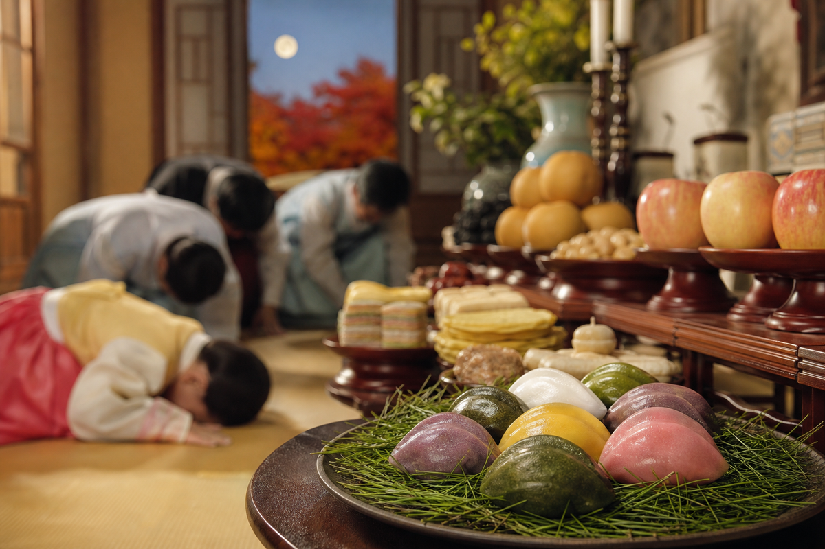
1 Chuseok is a Korean festival of harvest. It takes place each autumn on the 15th day of the eighth month of the lunar calendar, during the full moon. Chuseok is actually a three-day festival with celebrations before and after Chuseok Day. Many Asian countries celebrate a similar mid-autumn moon festival under other names.

2 Like American and Canadian Thanksgiving, Chuseok centers around family get-togethers and feasts. The traditional food served on Chuseok Day is songpyeon, half-moon rice cakes. These carefully crafted rice cakes are filled with sesame seeds, beans, or chestnuts and then shaped into crescents. They are placed on a bed of pine needles before being steamed. Well-prepared songpyeon symbolizes good luck.

3 Showing respect to ancestors is also central to Chuseok. Many Korean families use this holiday to visit and clean up their ancestors' graves, and they bring food offerings.

4 Traditional Korean games such as ssireum (Korean wrestling), tug-of-war, and neolttwigi (seesaw jumping) are customary during Chuseok. People also enjoy dancing and singing together under the harvest moon.

Comprehension
Q Why did the Pilgrims leave England?

Q What happened to the Pilgrims during their first winter in America?

Q How did the settlers learn to survive in their new land?

Q Why is Canadian Thanksgiving earlier than American Thanksgiving?

Q When does Chuseok take place?

Q How are songpyeon made?

Q What do many Korean families do to show respect to their ancestors during Chuseok?

Compare & Contrast
Fill in the table using the readings and your own knowledge.
 | Thanksgiving | Chuseok
When
Traditional food
Main activities
Origin / meaning
Idioms & Expressions
Expression | Meaning
grateful / thankful / appreciative | thankful
show one's gratitude | to show how grateful you are
thank goodness / thank heavens | an expression used to express relief
thanks a million | thank you very much
thank one's lucky stars | to feel grateful because you were very lucky
count one's blessings | to be very thankful for all that you have
feel stuffed / be stuffed | to feel very full from eating a lot
go cold turkey / quit ~ cold turkey | to quit a habit all at once, not gradually
talk turkey | to discuss a deal very seriously

Choose one of the expressions above to complete each sentence.
1 If the owner of the business really wants to sell, he will ____________________.
2 I am very ____________________ to you for all your help.
3 Last night he threw a full package of cigarettes in the garbage. He decided to ____________________.
4 You can ____________________ that a doctor was close by when you had your heart attack.
5 Thanksgiving is a day for all of us to ____________________.
6 ____________________ for everything you have done for me!
7 ____________________ you arrived safely! We were very worried about you.
8 I can't eat another thing! I feel ____________________.

Discussion
Q Which festival would you rather take part in, Thanksgiving or Chuseok? Why?

Q Now that you're married, how has Chuseok changed for you? Do you visit both families?

Q Many Koreans say Chuseok is more stressful than relaxing. Do you agree?

Q If you hosted a Thanksgiving dinner in Korea, what would you serve?

